  - Student/team member’s first name
  - CREST Award Level
  - Project title
  - Mentor name
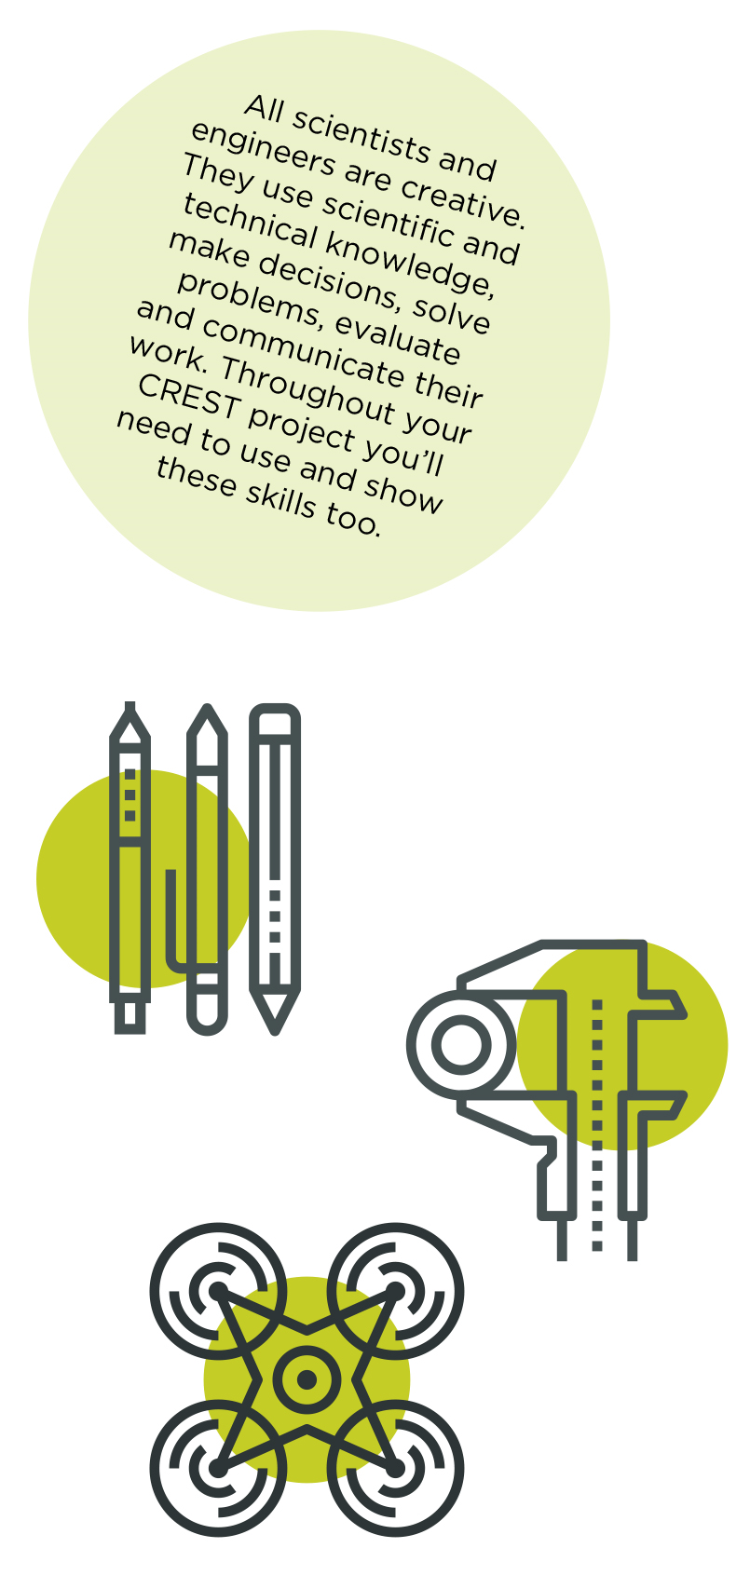

This Profile form is suitable for CREST Bronze, Silver and Gold Awards. Always use in conjunction with corresponding Student Guide Documents.

Please fill in this profile form and submit it along with your report. This a requirement for your submission and an opportunity for you to present clearly to the assessor how you have met the CREST criteria and reflect in your project.

If you are working in a group, make sure that you fill in and submit a separate Student Profile Form for each individual.

Criteria | Where do you show this in your report or project record? | Your notes to the assessor (optional)

1 – Planning your project

1.1 You have set a clear aim for the project and have broken it down into smaller objectives | Example: Page 2, paragraph 5
1.2 You have explained a wider purpose for the project
1.3 You have identified a range of approaches to the project
1.4 You have described your plan for the project and why you chose that approach
1.5 You have planned and organised your time well

2 – Throughout your project

2.1 You have made good use of the materials and people available
2.2 You have researched the background to the project and acknowledged your sources appropriately

3 – Finalising your project

3.1 You have made logical conclusions and explained the implications for the wider world
3.2 You have explained how your actions and decisions affected the project’s outcome
3.3 You have explained what you have learnt and reflected on what you could improve

4- Project-wide criteria

4.1 You have shown understanding of the science behind your project, appropriate to the Award level
4.2 You have made decisions to direct the project, taking account of ethical and safety issues
4.3 You have shown creative thinking

4.4 You have identified and overcome problems successfully
4.5 You have explained your project clearly, in writing or conversation

Personal reflections
Now that you’ve finished your project, use this space to add further thoughts on what you did and evaluate each stage of the project process. The CREST Gold Award student guide gives an example of what to include. You can continue on a separate sheet if necessary and use diagrams or pictures if you want to.
- How my project was successful/not successful
- What I learned
- What impact the results of my project might have on other people/the wider world
- What I would have done to improve my work
- What I’d do to develop the project in the future

My mentor
What role did your mentor have in your project?
Ask your mentor to confirm that this project is your work by signing below.
  - Signature of mentor
  - Date

  - Space for further notes/ drawings/ reflections (optional)...

